ENV-501 Material and Energy Flow Analysis
Binder, Moreau, Felix Martin Del Campo, Hecher
Fall 2023

Name: _____________________
Sciper: _____________________

Intermediate Exam
Thursday, 23 November 2023
Duration 8:15 to 10:15

Part 1: Material Flow Analysis (30 points)
Questions
- Describe mathematically the system illustrated in Figure 1, i.e. the system equations for the stocks and the equations for the flows (do not solve). List the chosen parameters and describe them briefly (8 points).
I₁ = F₁₂ + F₁₅
F₁₂ + F₃₂ = F₂₃ + F₂₅
F₂₃ = F₃₂ + F₃₄
ΔS4 = I2 + F34 - F45 - E
ΔS₅ = F₁₅ + F₂₅ + F₄₅
- Implement an internal recycling loop by introducing a recycled used aluminum flow from the consumption process into the foundry process.
a) Describe mathematically the equation for the new consumption stock (2 points).
ΔS4 = I2 + F34 - F42 - F45 - E
b) Describe mathematically the transfer coefficient of the recycled used aluminum flow. In addition, describe mathematically the relationship between this transfer coefficient and the export (5 points).
K₄₂ = F₄₂ / (I₂ + F₃₄)
F₃₄= ΔS₄ - I₂+ F₄₂ + F₄₅ + E
K₄₂ = F₄₂ / (ΔS₄+ F₄₂ + F₄₅ + E)
c) Describe the relationship between the transfer coefficient of the recycled used aluminum flow and the mineral import input flow in the case where consumption remains constant. What is the percentage reduction in imports with a recycling rate of 87% (6 points)?
Coefficient de transfert K42 = 0.87
F42 = K42 ∙ F34 = 0.87 ∙ 15 = 13.05 kg/hab/an
K12 = F12 / I1 = 16 / 16.5 = 0.97
I1 = F12 / K12 = (16 - 13.05) / 0.97 = 3.04 kg/hab/an
Imports decrease with 82 percent

Part 2: Spatial Material Flow Analysis (10 points)
Spatial analysis of material flows and stocks can greatly improve resource management, in particular reuse and recycling. This part is inspired by the work of Tanikawa et al. 2014. Figure 2 below represents the lost material stock of buildings in Sanriku and Ishinomaki due to the Great East Japan Earthquake in 2011, in tons (TerraMetrics 2013; map Data SIO, NOAA, U.S. Navy, NGA, GEBCO, and Cnes/Spot Image 2013). Buildings on the east coast of Japan included wooden houses, up to three story building structures made of steel and reinforced concrete buildings.
Based on the results shown in Figure 2, briefly explain how you would split the lost material stock between wood, steel and aggregates (7 points). State one advantage and one disadvantage of your approach (3 points).
Broadly:
*Identify buildings impacted, and at what degree (e.g. through disaster reports, images)
*Classification of building by main material (e.g., wood, steel, aggregate)
*Estimate building area/volume
*Apply material intensities per building area/volume
*Summarize all materials by building (bottom-up)
Advantages: e.g. generalization gives quick results
Disadvantages: e.g. due to generalization, precise results on material stocks data may be lacking
2 points: Only classifying by the color of the graph (at least some classification of materials).
3 points: Assuming city areas have more concrete and rural areas have more wood (at least a certain level of classification of materials, by clustering and other broad assumptions).
4 points: Clustering and also assigning certain material intensities, classifying by construction period, etc.
5 points: Clustering and also assigning certain material intensities, classifying by construction period, building archetypes, but lacks further description of steps.
6 points: More complete description of steps but misses a bit on the steps for estimation.
7 points: Identification of impacted buildings, classification by the main material, material intensities, summarizing the materials, and arriving at a final result. Overall, a more straightforward procedure.

Figure 2: Lost material stock of buildings in Sanriku and Ishinomaki (tons)
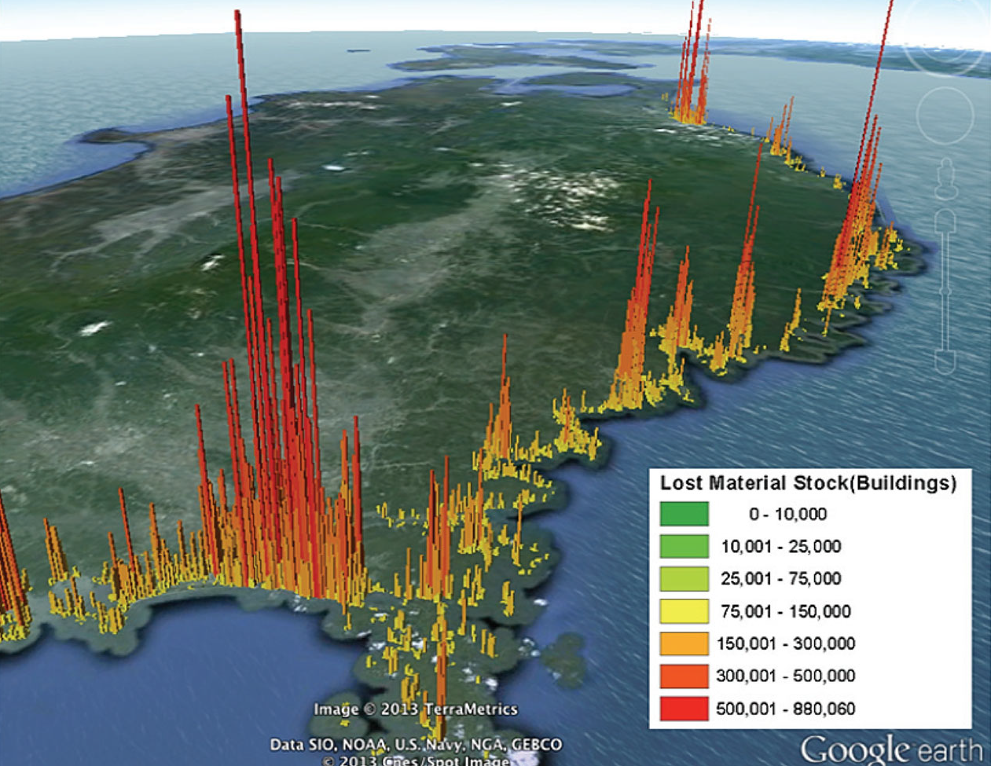
Part 3: Input Output Analysis (20 points)
Financial services represent an important part of economic activities in Switzerland. In monetary terms, approximately 5% of gross domestic product is the result of financial activities, excluding but equivalent to insurances. The environmental impact of such activities in Switzerland remains small, but much of the funding remains dedicated to extractive industries, fossil fuels, metallic and non-metallic minerals. This is much talked about, thanks to citizens and associations holding private banks as well as the national bank accountable. The value added of financial services means jobs in the sector are well paid, and much of these high wages are spent on luxury cars and air travel. In fact, recent research has shown that if the impact generated by employees and their lifestyles were factored in the impact of each economic activity, banking would be just as damaging as extractive industries.
Your task is to estimate the impact of fossil fuel consumption and emissions from transportation associated with financial activities. The direct consumption of fuels corresponds to approximately 250’000 and 6 million tons of CO₂ emissions per year as a result of financial and transport activities, respectively. Households, which represent the largest share of final consumption, spend approximately 8 billion swiss francs (CHF) on financial services and 9.4 billion in transportation.
A quick look at economic input output data allows you to establish the links between both activities, financial services and transportation, summarized in the table below, in million CHF.
 | Financial services | Transport | Output
Financial services | 16’300 | 600 | 70’000
Transport | 110 | 420 | 30’000
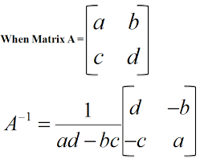
Questions
- Considering the interactions between both financial services and transport, estimate the CO₂ emissions from the transport sector induced by the final consumption of financial services from Swiss households (12 points)
- Are your results over- or underestimating the actual emissions? Briefly explain why and how you would improve your estimate (8 points)

